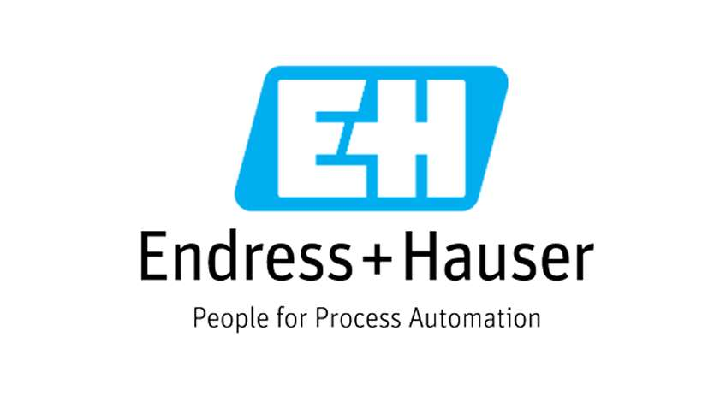
Technical Submittal
Jan 2021
Prepared for Endress + Hauser, Waluj Aurangabad

Dock Leveller:

Contactor Name:
Shubhshree Engineering and Constructions Pvt Ltd
401-404, Sai Business centre, Osmanpura
Aurangabad-431005, MH, India.

Supplied Name: NIHVA Technologies Pvt Ltd

Prepared by,
Shubhshree Engineering and Constructions Pvt Ltd
401-404, Sai Business centre, Osmanpura
Aurangabad-431005, MH, India.

Table of Contents

- Introduction
- BOQ
- GA Drawing
- Technical submittals
- Deviation List

- Introduction

NIHVA Technologies Pvt Ltd, Pune

NIHVA’s Head Office & manufacturing facility is located in Pune in Maharashtra (India) & sales office at various metro cities.
NIHVA is young and growing company, having experience of 7 years in industrial market. NIHVA specializes in providing integrated solutions in Door Automation & Automation Solutions.
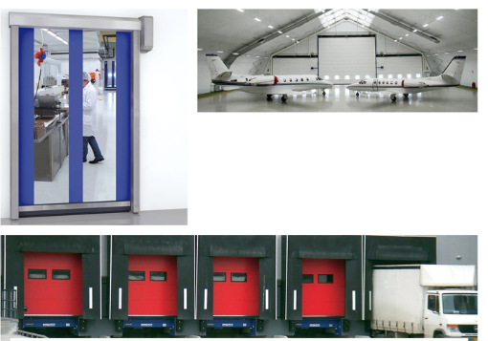

Apart from this NIHVA is also equipped in providing water management and drainage solutions (external and internal).

- BOQ & Compliance
   |  |  |  | 
PROJECT: UDAAN AT MIDC WALUJ, AURANGABAD, MAHARASHTRA, INDIA.
BOQ PART - M - Equipments
SR  NO. | Description | PHASE-1 QTY | PHASE-2 QTY | TOTAL QTY | UNIT | Remark
1 | Dock Levellers
 | Supply and fixing Electro- Hydraulic Dock Leveller of hot deep galvanised steel ) type radius lip with pair of super bummer of Approved make of size width 2000mm X 2500mm. Carrying capacity: point load of 6T, UDL of 15T and comprising of CE European certification built in conformity with EN 1398, platform with hinged lip made of profiled and anti-slip steel, pair of super bumpers - 150mm x 80mm x 400mm with heavy steel support, Hydraulic power pack suitable for UDL of 10T, EN1398 totally concentrated on one axle of fork lift truck, divided on two wheel, EN 1398 totally concentrated on one axle of fork lift truck, divided on two wheel prints of 150x 150mm at 1m distance.  Interlocked with sectional door and scissor lift. | 2 | 2 | 4 | NOS | Compliance with Deviation

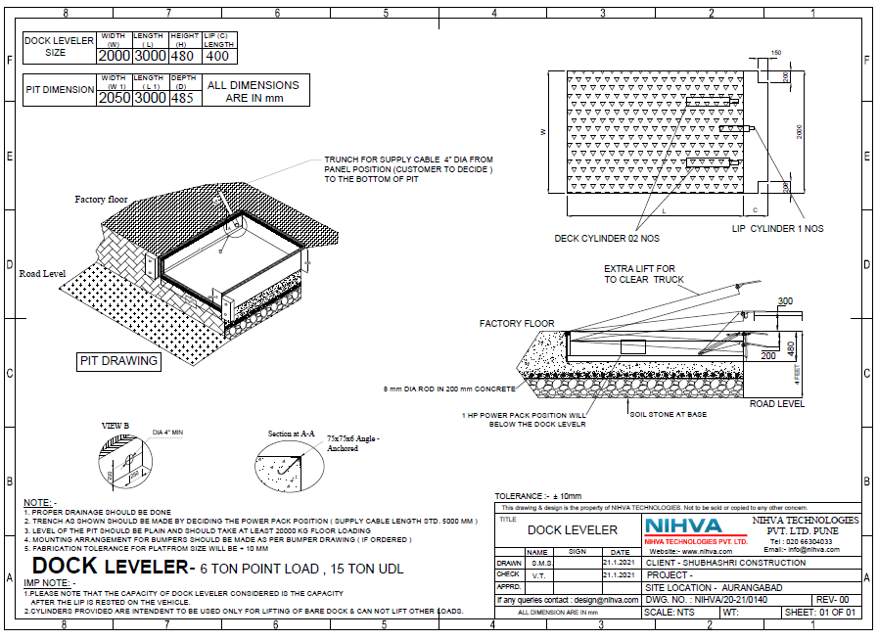
- GA Drawing

4. Technical submittals

Hydraulic Dock leveller: Hot Dip Galvanised
Sr. NO | Description | Specification
1 | Capacity | 6 Ton Point Load ( 15 Ton UDL)
2 | Platform Size | 2000 mm (W) X 3000 mm (L)
3 | Shut Height | 480 mm
4 | Dock Operation Mode | AC Power pack Hydraulically Operated
5 | Lip Operation mode | Hydraulic
6 | Operation Control | Through Panel by push button.
7 | Loading Platform height from road | 1200 -1300
8 | Travel above & below dock leveler | (+) 300 / (-)250
9 | Lip Size | 2000 X 400
10 | Clear Pit dimensions | 2050(w) X 3000(l) X 485 (h)
11 | Hydraulic Power pack | Standard with Rexroth Gear Pump
12 | Motor rating | 1 HP , Siemens
13 | Safety Valve set pressure | 120 kg/cm²
14 | Volume of hydraulic Oil receiver | 7 Liter (Servo-Grade 68)
15 | Hose | Parker Hoses
16 | No. of Deck Cylinder | 2 Nos.
17 | Lip cylinder | 1 No.
18 | Dock bumper | Pair of Dock bumper of EPDM rubber
19 | Deck Plate thickness | 8mm
20 | Lip Plate thickness | 14mm

5. Deviation List

Sr. No. | Description | Remarks
1 | NIHVA Hot Dip Galvanized Dock leveler  (W) 2000 mm X (L) 2500 mm | Size Change : (W) 2000 mm X (L) 3000 mm
3 | Any civil / masonry/structural work required | In Client Scope
4 | Dock Bumper size : As per BOQ -150 X80 X 400 | NIHVA Dock Bumper - 254 X 100 X330
5 | In Case of any changes in the layout as per site requirements after the shipment of material, the additional quantities and the wastage. | In Client Scope
6 | Conduits, Cables required | In Client Scope
8 | Interlocking with scissor lift & Sectional overhead door | In client scope, we will give potential free contact.

